AF Sine and Square Wave Generator:
The block diagram of an AF Sine and Square Wave Generator audio oscillator is illustrated in Fig. 8.4.
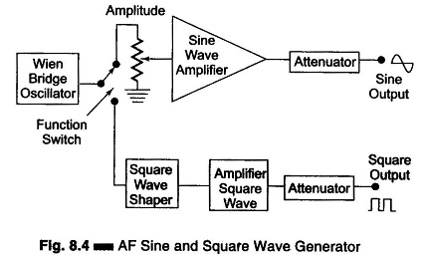
The signal generator is called an oscillator. A Wien bridge oscillator is used in this generator. The Wien bridge oscillator is the best for the audio frequency range. The frequency of oscillations can be changed by varying the capacitance in the oscillator. The frequency can also be changed in steps by switching in resistors of different values.
The output of the Wien bridge oscillator goes to the function switch. The function switch directs the oscillator output either to the sine wave amplifier or to the square wave shaper. At the output, we get either a square or sine wave. The output is varied by means of an attenuator.
The instrument generates a frequency ranging from 10 Hz to 1 MHz, continuously variable in 5 decades with overlapping ranges. The output sine wave amplitude can be varied from 5 mV to 5 V (rms).The output is taken through a push-pull amplifier. For low output, the impedance is 600Ω. The square wave amplitudes can be varied from 0 – 20 V (peak). It is possible to adjust the symmetry of the square wave from 30 – 70%. The instrument requires only 7 W of power at 220 V – 50 Hz.
The front panel of a signal generator consists of the following.
- Frequency selector – It selects the frequency in different ranges and varies it continuously in a ratio of 1 : 11. The scale is non-linear.
- Frequency multiplier – It selects the frequency range over 5 decades, from 10 Hz to 1 MHz.
- Amplitude multiplier – It attenuates the sine wave in 3 decades, x 1, x 0.1 and x 0.01.
- Variable amplitude – It attenuates the sine wave amplitude continuously.
- Symmetry control – It varies the symmetry of the square wave from 30% to 70%.
- Amplitude – It attenuates the square wave output continuously.
- Function switch – It selects either sine wave or square wave output.
- Output available – This provides sine wave or square wave output.
- Sync – This terminal is used to provide synchronisation of the internal signal with an external signal.
- On-Off Switch.

Pulse and Square Wave Generator Block Diagram (Laboratory Type):
Pulse and Square Wave Generator are used as measuring devices in combination with a CRO. They provide both quantitative and qualitative information of the system under test. They are made use of in transient response testing of amplifiers. The fundamental difference between a pulse generator and a square wave generator is in the duty cycle.
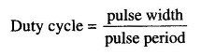
A square wave generator has a 50% duty cycle. 8.9.1

Feature | Square Wave | Pulse Wave
Duty Cycle | Exactly 50% | Variable (Any %)
On/Off Time | Equal | Generally unequal
Periodicity | Periodic (Repeating) | Can be single or periodic
Application | Digital Clocks/Logic | PWM, Timing, Signaling

Requirements of a Pulse:
- The pulse should have minimum distortion, so that any distortion, in the display is solely due to the circuit under test.
- The basic characteristics of the pulse are rise time, overshoot, ringing, sag, and undershoot.
- The pulse should have sufficient maximum amplitude, if appreciable output power is required by the test circuit, e.g. for magnetic core At the same time, the attenuation range should be adequate to produce small amplitude pulses to prevent over driving of some test circuit.
- The range of frequency control of the pulse repetition rate (PRR) should meet the needs of the experiment. For example, a repetition frequency of 100 MHz is required for testing fast circuits. Other generators have a pulse-burst feature which allows a train of pulses rather than a continuous
- Some pulse generators can be triggered by an externally applied trigger signal; conversely, pulse generators can be used to produce trigger signals, when this output is passed through a differentiator circuit.
- The output impedance of the pulse generator is another important In a fast pulse system, the generator should be matched to the cable and the cable to the test circuit. A mismatch would cause energy to be reflected back to the generator by the test circuit, and this may be re-reflected by the generator, causing distortion of the pulses.
- DC coupling of the output circuit is needed, when dc bias level is to be
The basic circuit for pulse generation is the asymmetrical multi-vibrator. A laboratory type square wave and pulse generator is shown in Fig. 8.6.
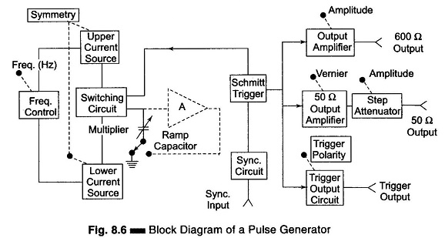
The frequency range of the instrument is covered in seven decade steps from 1 Hz to 10 MHz, with a linearly calibrated dial for continuous adjustment on all ranges.
The duty cycle can be varied from 25 – 75%. Two independent outputs are available, a 50 Q source that supplies pulses with a rise and fall time of 5 ns at 5 V peak amplitude and a 600 Q source which supplies pulses with a rise and fall time of 70 ns at 30 V peak amplitude. The instrument can be operated as a free-running generator, or it can be synchronized with external signals.
The basic generating loop consists of the current sources, the ramp capacitor, the Schmitt trigger and the current switching circuit, as shown in Fig. 8.7.
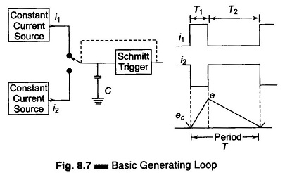
The upper current source supplies a constant current to the capacitor and the capacitor voltage increases linearly. When the positive slope of the ramp voltage reaches the upper limit set by the internal circuit components, the Schmitt trigger changes state. The trigger circuit output becomes negative and reverses the condition of the current switch. The capacitor discharges linearly, controlled by the lower current source. When the negative ramp reaches a predetermined lower level, the Schmitt trigger switches back to its original state. The entire process is then repeated. The ratio i₁/i₂ determines the duty cycle, and is controlled by symmetry control. The sum of i₁ and i₂ determines the frequency. The size of the capacitor is selected by the multiplier switch.
The unit is powered by an internal supply that provides regulated voltages for all stages of the instrument.

How an Arbitrary Waveform Generator Works
The core idea of an Arbitrary Waveform Generator (AWG) is to define a signal digitally and then convert it into a precise analog output., with precision. It does not produce fixed mathematical waves, but rather recreates a waveform on a point by point basis by reference to stored data.
In the first step, the user specifies the desired waveform by software or by the instrument interface. This waveform is described by a sequence of digital representation of amplitude and is stored in the internal memory of the AWG. These values are then read by a precise clock at a fixed rate which is called the sampling rate.
The digital data is then transmitted to a Digital-to-Analog Converter (DAC) which converts the digital samples to a voltage level. The signal obtained is processed by filters and output amplifiers to regularize the signal and adjust the desired amplitude.
Lastly, the AWG produces a clean continuous analog signal at the output, that reproduces the original shape of the waveform with accuracy. This is because through this process, AWGs can produce very complex and natural signals in order to test and analyze more sophisticated electronics.
Understanding how an AWG works is essential to using it effectively. Although modern AWGs appear complex, their working principle is logical and systematic.

Basic Working Principle
At its core, an arbitrary waveform generator operates using the following steps:
- Waveform Definition
- Digital Storage
- Clocked Playback
- Digital-to-Analog Conversion
- Signal Conditioning and Output

What is Wave Analyzer?:
It can be shown mathematically that any complex waveform is made up of a fundamental and its harmonics. It is often desired to measure the amplitude of each harmonic or fundamental individually. This can be performed by instruments called wave analyzers. This is the simplest form of analysis in the frequency domain, and can be performed with a set of tuned filters and a voltmeter. Wave analyzers are also referred to as frequency selective voltmeters, carrier frequency voltmeters, and selective level voltmeters. The Basic wave analyzer instrument is tuned to the frequency of one component whose amplitude is measured.
This instrument is a narrow band superheterodyne receiver, similar to a spectrum analyzer (discussed later). It has a very narrow pass-band. A meter is used for measurement, instead of a CRT. Wave analyzers are used in the low RF range, below 50 MHz and down through the AF range. They provide a very high frequency resolution.
Some wave analyzers have the facility of automatic frequency control, in which the tuning automatically locks to a signal. This makes it possible to measure the amplitude of signals that are drifting in frequency by amounts that would carry them outside the widest pass-band available.
When a sinusoidal signal is applied to the input of an ideal linear amplifier, it produces a sinusoidal output waveform. However, in most cases the output waveform is not an exact replica of the input signal because of different types of distortion. The amount by which the output waveform of an amplifier differs from the input waveform is a measure of the distortion introduced by the inherent non-linear characteristics of the active devices.
Harmonic distortion analyzers measure the total harmonic content in the waveforms. It can be shown mathematically that an amplitude distorted sine wave is made up of pure sine wave components, including the fundamental frequency f of the input signal, and harmonic multiples of the fundamental frequency, 2f, 3f, 4f etc.
Harmonic distortion can be quantitatively measured very accurately with a harmonic distortion analyzer, generally called a distortion analyzer.
The total harmonic distortion or factor is given by

where D₂, D₂, D₃ … represent the second harmonic, third harmonic, etc. respectively.
The distortion analyzer measures the total harmonic distortion without indicating the amplitude and frequency of each component waves.
Signal analysis of both random and periodic signals in the frequency domain is used extensively in electronic and telecommunications. The frequency stability and spectral purity of signal sources can be measured by the use of these signal analyzers.
These signal analyzers can be used along with a frequency generator or a source of white or pseudo-random noise to measure the frequency response of amplifiers, filters or other networks.
The operational characteristics of a transreceiver and communication system are determined by measuring various parameters, such as spectral purity of the carrier wave, spectral power distribution of the amplitude or frequency modulated wave, signal distortion, and the systems signal to noise ratio.
Such analysis is provided by a wave analyzer, distortion analyzer, spectrum analyzer, and digital fourier analyzer.

Block Diagram of Basic Wave Analyzer:
A basic wave analyzer is shown in Fig. 9.1(a). It consists of a primary detector, which is a simple LC circuit. This LC circuit is adjusted for resonance at the frequency of the particular harmonic component to be measured.
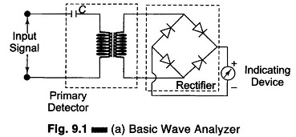
The intermediate stage is a full wave rectifier, to obtain the average value of the input signal. The indicating device is a simple dc voltmeter that is calibrated to read the peak value of the sinusoidal input voltage.
Since the LC circuit is tuned to a single frequency, it passes only the frequency to which it is tuned and rejects all other frequencies. A number of tuned filters, connected to the indicating device through a selector switch, would be required for a useful Wave analyzer.

Types of Wave Analyzer:
There are two types of Wave Analyzer namely,
- Frequency Selective Wave Analyzer
- Heterodyne Wave Analyzer

Applications of Wave Analyzer:
- It is used to measures the harmonic distortion of the signal
- It is used to measuring the amplitude of the selected frequency component in the signal
- It is used to decrease the sound and Vibration from electrical machines
- It is used as a harmonic distortion analyzer
- It is used for analyzing the DC Component with periodic signals
- It is used as a automatic frequency controller
- It is used in electrical measurements

Frequency Selective Wave Analyzer:
The Frequency Selective Wave Analyzer consists of a very narrow pass-band filter section which can be tuned to a particular frequency within the audible frequency range (20 Hz – 20 kHz). The block diagram of a wave analyzer is as shown in Fig. 9.1(b).
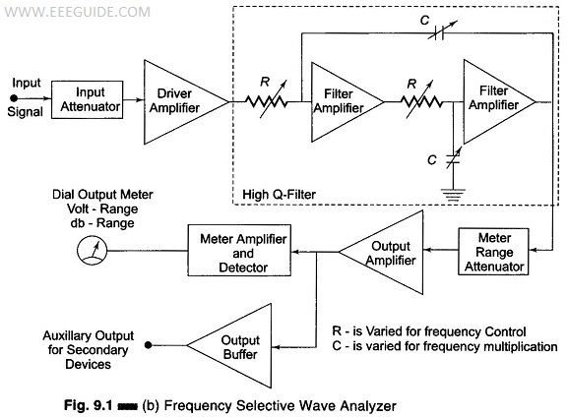
The complex wave to be analyzed is passed through an adjustable attenuator which serves as a range multiplier and permits a large range of signal amplitudes to be analyzed without loading the amplifier.
The output of the attenuator is then fed to a selective amplifier, which amplifies the selected frequency. The driver amplifier applies the attenuated input signal to a high-Q active filter. This high-Q filter is a low pass filter which allows the frequency which is selected to pass and reject all others. The magnitude of this selected frequency is indicated by the meter and the filter section identifies the frequency of the component. The filter circuit consists of a cascaded RC resonant circuit and amplifiers. For selecting the frequency range, the capacitors generally used are of the closed tolerance polystyrene type and the resistances used are precision potentiometers. The capacitors are used for range changing and the potentiometer is used to change the frequency within the selected pass-band, Hence this wave analyzer is also called a Frequency selective voltmeter.
The entire AF range is covered in decade steps by switching capacitors in the RC section.
The selected signal output from the final amplifier stage is applied to the meter circuit and to an untuned buffer amplifier. The main function of the buffer amplifier is to drive output devices, such as recorders or electronics counters.
The meter has several voltage ranges as well as decibel scales marked on it. It is driven by an average reading rectifier type detector.
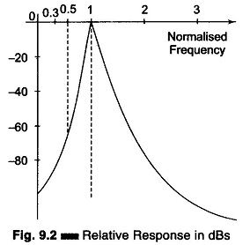
The wave analyzer must have extremely low input distortion, undetectable by the analyzer itself. The bandwidth of the instrument is very narrow, typically about 1% of the selective band given by the following response characteristics. (Fig. 9.2).

Heterodyne Wave Analyzer:
Wave analyzers are useful for measurement in the audio frequency range only. For measurements in the RF range and above (MHz range), an ordinary wave analyzer cannot be used. Hence, special types of wave analyzers working on the principle of heterodyning (mixing) are used. These wave analyzers are known as Heterodyne Wave Analyzer.
In this wave analyzer, the input signal to be analyzed is heterodyned with the signal from the internal tunable local oscillator in the mixer stage to produce a higher IF frequency.
By tuning the local oscillator frequency, various signal frequency components can be shifted within the pass-band of the IF amplifier. The output of the IF amplifier is rectified and applied to the meter circuit.
An instrument that involves the principle of heterodyning is the Heterodyning tuned voltmeter, shown in Fig. 9.3.
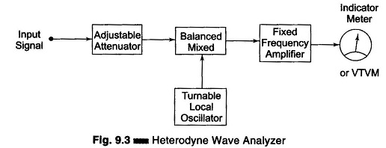
The input signal is heterodyned to the known IF by means of a tunable local oscillator. The amplitude of the unknown component is indicated by the VTVM or output meter. The VTVM is calibrated by means of signals of known amplitude.
The frequency of the component is identified by the local oscillator frequency, i.e. the local oscillator frequency is varied so that all the components can be identified. The local oscillator can also be calibrated using input signals of known frequency. The fixed frequency amplifier is a multistage amplifier which can be designed conveniently because of its frequency characteristics. This analyzer has good frequency resolution and can measure the entire AF frequency range. With the use of a suitable attenuator, a wide range of voltage amplitudes can be covered. Their disadvantage is the occurrence of spurious cross-modulation products, setting a lower limit to the amplitude that can be measured.
Two types of selective amplifiers find use in Heterodyne wave analyzers. The first type employs a crystal filter, typically having a centre frequency of 50 kHz. By employing two crystals in a band-pass arrangement, it is possible to obtain a relatively flat pass-band over a 4 cycle range. Another type uses a resonant circuit in which the effective Q has been made high and is controlled by negative feedback. The resultant signal is passed through a highly selective 3-section quartz crystal filter and its amplitude measured on a Q-meter.
When a knowledge of the individual amplitudes of the component frequency is desired, a heterodyne wave analyzer is used.
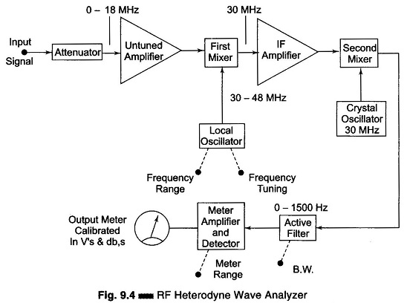
A modified heterodyne wave analyzer is shown in Fig. 9.4. In this analyzer, the attenuator provides the required input signal for heterodyning in the first mixer stage, with the signal from a local oscillator having a frequency of 30 – 48 MHz.
The first mixer stage produces an output which is the difference of the local oscillator frequency and the input signal, to produce an IF signal of 30 MHz. This IF frequency is uniformly amplified by the IF amplifier. This amplified IF signal is fed to the second mixer stage, where it is again heterodyned to produce a difference frequency or IF of zero frequency.
The selected component is then passed to the meter amplifier and detector circuit through an active filter having a controlled band-width. The meter detector output can then be read off on a db – calibrated scale, or may be applied to a secondary device such as a recorder.
This wave analyzer is operated in the RF range of 10 kHz – 18 MHz, with 18 overlapping bands selected by the frequency range control of the local oscillator. The bandwidth, which is controlled by the active filter, can be selected at 200 Hz, 1 kHz and 3 kHz.

Harmonic Distortion Analyzer:
A Harmonic Distortion Analyzer measures the total harmonic power present in the test wave rather than the distortion caused by each component. The simplest method is to suppress the fundamental frequency by means of a high pass filter whose cut off frequency is a little above the fundamental frequency. This high pass allows only the harmonics to pass and the total harmonic distortion can then be measured. Other types of Harmonic Distortion Analyzer based on fundamental suppression are as follows.

1. Employing a Resonance Bridge:
The bridge shown in Fig. 9.5 is balanced for the fundamental frequency, i.e. L and C are tuned to the fundamental frequency. The bridge is unbalanced for the harmonics, i.e. only harmonic power will be available at the output terminal and can be measured. If the fundamental frequency is changed, the bridge must be balanced again. If L and C are fixed components, then this method is suitable only when the test wave has a fixed frequency. Indicators can be thermocouples or square law VTVMs. This indicates the rms value of all harmonics. When a continuous adjustment of the fundamental frequency is desired, a Wien bridge arrangement is used as shown in Fig. 9.6.
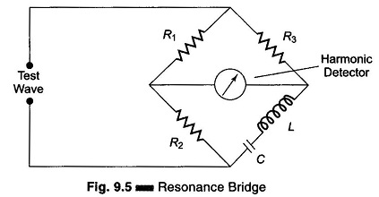

2. Wien’s Bridge Method:
The bridge is balanced for the fundamental frequency. The fundamental energy is dissipated in the bridge circuit elements. Only the harmonic components reach the output terminals. The harmonic distortion output can then be measured with a meter. For balance at the fundamental frequency, C₁ = C₂ = C, R₁ = R₂ = R, R₃ = 2R₄.
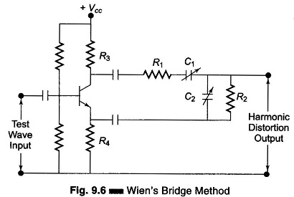

3. Bridged T-Network Method:
Referring to Fig. 9.7 the, L and C’s are tuned to the fundamental frequency, and R is adjusted to bypass fundamental frequency. The tank circuit being tuned to the fundamental frequency, the fundamental energy will circulate in the tank and is bypassed by the resistance. Only harmonic components will reach the output terminals and the distorted output can be measured by the meter. The Q of the resonant circuit must be at least 3-5.
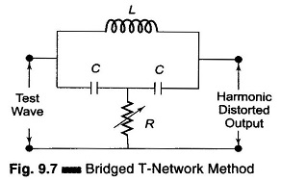
One way of using a bridge T-network is given in Fig. 9.8.
The switch S is first connected to point A so that the attenuator is excluded and the bridge T-network is adjusted for full suppression of the fundamental frequency, i.e. minimum output. Minimum output indicates that the bridged T-network is tuned to the fundamental frequency and that the fundamental frequency is fully suppressed.
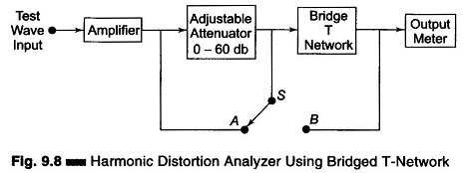
The switch is next connected to terminal B, i.e. the bridged T-network is excluded. Attenuation is adjusted until the same reading is obtained on the meter. The attenuator reading indicates the total rms distortion. Distortion measurement can also be obtained by means of a wave analyzer, knowing the amplitude and the frequency of each component, the Harmonic Distortion Analyzer can be calculated. However, distortion meters based on fundamental suppression are simpler to design and less expensive than wave analyzers. The disadvantage is that they give only the total distortion and not the amplitude of individual distortion components.

